VISVESVARAYA TECHNOLOGICAL UNIVERSITY
JNANA SANGAMA, BELAGAVI-590018

PROJECT PHASE II REPORT ON
“Project Title”
Submitted in partial fulfillment for the award of the degree of Bachelor of Engineering
in
Computer Science & Engineering

Submitted by:

Student Name1 USN1
Student Name2 USN2
Student Name3 USN3
Student Name4 USN4

Under the Guidance of Bandhavya G Assistant Professor Dept. of CSE, CIT NC

DEPARTMENT OF COMPUTER SCIENCE & ENGINEERING

CAMBRIDGE INSTITUTE OF TECHNOLOGY NORTH CAMPUS
KUNDANA, BENGALURU – 562110, KARNATAKA 2026– 2027

CAMBRIDGE INSTITUTE OF TECHNOLOGY NORTH CAMPUS
KUNDANA, BENGALURU – 562110, KARNATAKA

DEPARTMENT OF COMPUTER SCIENCE & ENGINEERING

CERTIFICATE

Certified that Student names Bearing USN’s, are Bonafide students of Cambridge Institute of Technology North Campus has successfully completed the project entitled “Project Title” in partial fulfillment of the Final Year of Bachelor of Engineering in Computer Science and Engineering of the Visvesvaraya Technological University Belagavi. During the academic Year 2026-2027.
It is certified that all corrections/suggestions indicated for Internal Assessment have been incorporated in the report deposited in the departmental Library. The project report has been approved as it satisfies the academic requirements in respect of the project work prescribed for the Bachelor of Engineering Degree.
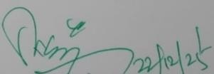
Signature of Guide Signature of HOD Signature of Principal

Bandhavya G Assistant Professor
Dr. Rajshekhar M Patil
Prof. and HOD
Dr. Prasad Naik Hamsavath Principal

Dept. of CSE, CIT NC. Dept. of CSE, CIT NC. CIT NC.

External Viva

Name of the Examiners Signature with Date

CAMBRIDGE INSTITUTE OF TECHNOLOGY NORTH CAMPUS
KUNDANA, BENGALURU – 562110, KARNATAKA

DEPARTMENT OF COMPUTER SCIENCE & ENGINEERING

DECLARATION

We, Ms. Student Names Bearing USN’s, respectively are students of VII semester, Computer Science and Engineering, Cambridge Institute of Technology North Campus, hereby declare that the Project Entitled “Project Title” has been carried out by us and submitted in partial fulfillment of the course requirements of VII semester Bachelor of Engineering in Computer Science and Engineering as prescribed by Visvesvaraya Technological University, Belagavi, During the Academic Year 2026-2027.
We also declare that, to the best of our knowledge and belief, the work reported here does not form part of any other report based on which a degree or award was conferred on an earlier occasion on by any other student.

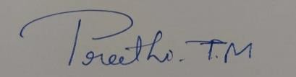
Date:
Place: Bangalore
Signature of(Candidates)

Name1 USN 1
Name 2 USN2
Name 3 USN3
Name 4 USN4

ACKNOWLEDGEMENT

We would like to place on record our deep sense of gratitude to Management, Cambridge Group of Institutions, Bangalore, India for providing excellent infrastructure and academic environment at CIT NC without which this work would not have been possible.
We extremely thankful to Dr. Prasad Naik Hamsavath, Principal, CIT NC., Bengaluru, for providing us with the academic ambiance and everlasting motivation to carry out this work and shaping our careers.
We express our sincere gratitude to Dr. Rajshekhar M Patil, HOD, Dept. of Computer Science and Engineering, CITNC, Bengaluru, for his stimulating guidance, continuous encouragement, and motivation throughout the present work.
We also wish to extend our thanks to Project Coordinator Prof. Bandhavya G, Assistant Professor, Dept. of CSE, CIT NC, Bangalore, for her critical, insightful comments, guidance and constructive suggestions to improve the quality of this work.
We consider it a privilege to express our sincere thanks to our project internal guide Bandhavya G (respective guide names), Assistant Professor, Dept. of CSE CITNC, Bengaluru, for his valuable suggestions and constant encouragement throughout our work. Her expert guidance at every stage of the project has been instrumental in shaping our ideas and improving the quality of our research. We are deeply grateful for the time and effort she dedicated to reviewing our progress and providing insightful feedback. His support and motivation have greatly contributed to the successful completion of our project.

Name1 USN 1
Name2 USN 2
Name3 USN 3
Name4 USN 4

ABSTRACT

“Project Title” Animal identification plays an important role in wildlife conservation, public safety, agriculture, and urban management in India, where both wild and pet animals frequently interact with human environments. With increasing incidents of wild animals entering residential areas and the growing number of domestic pets, there is a need for an intelligent system that can accurately identify and classify animals. This project focuses on the identification of wild and pet animals in India using Artificial Intelligence (AI) and Deep Learning techniques. The proposed system uses image and video inputs captured through cameras or CCTV surveillance. These inputs are preprocessed and analyzed using convolutional neural networks (CNNs) to detect animals and classify them into wild animals (such as tiger, elephant, deer, monkey, etc.) and pet animals (such as dog, cat, cow, goat, etc.). The system is designed to work in real-time and provides accurate identification by drawing bounding boxes and displaying the animal category and species. This solution can assist forest departments, local authorities, and citizens in monitoring animal movement, preventing human–animal conflicts, and improving animal management systems. The project demonstrates how AI-based animal identification can contribute to safety, conservation efforts, and smarter surveillance systems in India

CONTENTS

TITLE
ABSTRACT I
TABLE OF CONTENTS II
LIST OF FIGURES II

CHAPTER CHAPTER NAME PAGE NO.

CHAPTER 1
1.1
1.2
1.3
1.4
CHAPTER 2
2.1
2.2

CHAPTER 3
3.1
3.2
3.3
3.4

INTRODUCTION PROBLEM STATEMENT OBJECTIVES
SCOPE OF THE PROJECT APPLICATIONS LITERATURE SURVEY EXISTING SYSTEM PROPOSED SYSTEM

SYSTEM REQUIREMENTS AND SPECIFICATIONS FUCNTIONAL REQUIREMENTS
NON-FUNCTIONAL REQUIREMENTS HARDWARE REQUIREMENTS SOFTWARE REQUIREMENTS

1-2
2-3
3-4
5
5-6

7-13
7
8-10

14-17
14-15
15-16
16
17

 | CHAPTER 4 |  | METHODOLOGY/ SYSTEM DESIGN | 18-32
 | 4.1 |  | MODEL / ARCHITECTURE / USE CASE DIAGRAM | 18-19
 | 4.2 |  | FLOWCHART / DATA FLOW / UML DIAGRAM | 20-21
CHAPTER 5 |  | IMPLEMENTATION MODULES METHODOLOGIES |  |  | 33-37
5.1 |  | DATABASE CREATION INTEGRATION(if any) |  |  | 33-34
5.2 |  | ALGORITHM USED |  |  | 34-35
5.3 |  | DEMONSTRATION OF WORKING PROTOTYPE |  |  | 36-37
CHAPTER 6 |  | SYSTEM TESTING |  |  | 38-42
6.1 |  | TESTING METHODOLOGIES AND TESTING RESULTS
CHAPTER 7 |  | RESULTS |  |  | 43-46
CHAPTER 8 |  | CONCLUSION AND FUTURE WORK |  |  | 47-50
8.1 |  | CONCLUSION |  |  | 47-48
8.2 |  | FUTURE WORK |  |  | 49-50
 |  | REFERENCE OR BIBLOGRAPHY |  |  | 50

LIST OF FIGURES

FIG. NO | FIG.NAME | PAGE.NO

AI-Driven Identification of Wild and Pet Animals

CHAPTER 1

INTRODUCTION

PROJECT DESCRIPTION
The project titled “AI-Driven Identification of Wild and Pet Animals” focuses on designing and implementing an intelligent system that can automatically identify and classify animals as wild or pet using Artificial Intelligence (AI) and Deep Learning techniques. With the increasing interaction between humans and animals in urban, rural, and semi-forest regions, there is a growing need for a fast, reliable, and automated animal identification system. Such a system can help improve safety awareness and support informed decision-making in scenarios involving animal encounters.
Traditional methods of animal identification rely heavily on manual observation and expert knowledge, which are time-consuming, error-prone, and impractical for real-time usage. These methods are not suitable for applications where quick identification is required. To overcome these limitations, the proposed project utilizes computer vision and deep learning to automate the process of animal identification using live image input.
At the core of the system is a Convolutional Neural Network (CNN) model based on MobileNetV2, which is trained on a dataset containing images of both wild and pet animals. MobileNetV2 is chosen due to its lightweight architecture and efficiency, making it suitable for real-time image classification tasks. The model learns distinctive visual features such as body structure, texture, shape, and appearance of animals, enabling it to perform accurate classification even under varying lighting conditions and background environments.
The system follows a structured processing pipeline that includes live image acquisition, image preprocessing, feature extraction, classification, and result display. A web-based application is developed to allow users to capture or upload live images of animals. These images are preprocessed to match the input requirements of the trained model and are then passed to the CNN for classification. The system outputs a clear prediction indicating whether the animal belongs to the Wild or Pet category, along with a confidence score to represent the reliability of the prediction.
The primary objective of the proposed system is binary classification of animals into wild and pet categories, which helps users quickly assess the nature of the animal. This classification

DEPT. OF CSE, CITNC 2025-26
Page | 1

AI-Driven Identification of Wild and Pet Animals

can be useful in increasing awareness and reducing uncertainty during animal encounters. The results are displayed through a simple and user-friendly web interface, making the system easy to use even for non-technical users.
The proposed system demonstrates how deep learning can be effectively applied to real-world animal identification problems. Although the current implementation focuses on live image-based classification, the system is designed in a modular and scalable manner, allowing future enhancements without major structural changes.
Overall, this project highlights the practical application of AI and deep learning in building intelligent animal identification systems. It provides a reliable foundation for further research and development in the field of automated animal monitoring while showcasing the effectiveness of CNN-based models such as MobileNetV2 for real-time image classification tasks.

PROBLEM STATEMENT
Accurate identification of animals using visual data is a challenging task in environments such as forests, agricultural lands, urban areas, and residential spaces. Traditional animal identification methods rely heavily on manual observation, expert knowledge, and human monitoring. These approaches are time-consuming, prone to errors, and not suitable for situations where quick and reliable identification is required. With increasing interaction between humans and animals, especially in urban and semi-urban regions, there is a growing need for an automated and intelligent animal identification system.
Existing visual monitoring systems are capable of capturing images but lack the ability to automatically interpret or classify animals present in the images. Manual analysis of captured images is inefficient and may lead to delayed responses. In many scenarios, the inability to quickly distinguish between wild and pet animals can result in safety concerns, crop damage, and increased human–animal conflict. Similarly, identifying domestic animals manually can be difficult, particularly in large or unfamiliar environments.
Currently, there is a lack of a reliable AI-based system that can automatically classify animals from live images into meaningful categories such as wild or pet. Variations in lighting conditions, background clutter, image quality, and viewing angles further complicate the

classification process. These challenges highlight the need for a robust and intelligent solution capable of performing accurate image-based animal classification.
Therefore, this project aims to address these limitations by developing an AI-driven image classification system using deep learning techniques. The proposed system focuses on analyzing live images, preprocessing them, and classifying animals into wild or pet categories using a trained Convolutional Neural Network (CNN) model. The solution is designed to be efficient, reliable, and suitable for real-time image-based usage through a web application.

OBJECTIVES
The primary goal of the project “AI-Driven Identification of Wild and Pet Animals” is to design and implement an intelligent system that uses artificial intelligence and deep learning techniques to automatically identify animals from live images and classify them into meaningful categories. The objectives of the project are divided into Primary Objectives, Secondary Objectives, and Technical Objectives for clarity and better understanding.

Primary Objectives

    - To design and develop an AI-based animal identification system that can automatically analyze live images and identify animals using deep learning techniques.
    - To implement a Convolutional Neural Network (CNN)–based classification model that can effectively distinguish between wild animals and pet animals based on visual features extracted from images.
    - To build a system that provides accurate classification results along with confidence scores, enabling users to understand the reliability of the predictions.
    - To reduce the dependency on manual animal identification, which is often time-consuming, error-prone, and impractical in real-time scenarios.
    - To demonstrate the practical application of computer vision and deep learning in solving real-world animal identification problems.

Secondary Objectives

- To develop a robust image classification system capable of handling variations in lighting conditions, background complexity, animal posture, distance from the camera, and image quality.
- To create a web-based user interface that allows users to easily capture or upload live images and receive classification results in a simple and understandable format.
- To ensure that the system performs real-time image-based predictions with minimal delay by using a lightweight and efficient deep learning model.
- To design the system architecture in a modular and scalable manner, enabling future enhancements such as video stream processing or advanced detection techniques without major changes to the core system.
- To improve user awareness and safety by providing quick identification of animals as wild or pet, helping users make informed decisions during animal encounters.
- To provide a foundation for intelligent animal monitoring systems that can be extended for use in agriculture, wildlife awareness, pet management, and environmental studies.

Technical Objectives

- To design and utilize a CNN-based deep learning architecture (MobileNetV2) that is suitable for efficient and accurate image classification.
- To preprocess input images by applying operations such as resizing, normalization, and format conversion to meet the input requirements of the trained model.
- To integrate the trained deep learning model with a backend server that handles image preprocessing and prediction requests.
- To implement a user-friendly web application interface that displays the predicted animal category (wild or pet) along with a confidence score.
- To evaluate system performance based on prediction accuracy, response time, and output consistency during testing with different live images.
- To ensure that the system operates reliably under normal real-world conditions and produces consistent results for valid inputs.

DEPT. OF CSE, CITNC 2025-26
Page | 4

SCOPE OF THE PROJECT
The scope of the project “AI-Driven Identification of Wild and Pet Animals” is focused on developing an intelligent, image-based animal classification system using deep learning techniques. The system is designed to analyze live images captured through a web application and classify animals into wild or pet categories. The scope of this project is limited to image-based classification and does not include continuous video stream processing or automated alert systems.
The project primarily addresses the problem of manual animal identification by automating the classification process using a Convolutional Neural Network (CNN) based on MobileNetV2. The system supports real-time image inference and displays classification results along with confidence scores to improve interpretability. The scope includes image preprocessing, feature extraction, classification, and result visualization through a user-friendly web interface.
The system is intended for educational, experimental, and awareness purposes, demonstrating how artificial intelligence and computer vision techniques can be applied to real-world problems. It is suitable for scenarios where quick identification of animals is required using captured images.
However, the scope of the current implementation does not include video surveillance, object detection, alert generation, multi-camera support, or automated notifications. These features are considered beyond the present scope and are planned as future enhancements.
Overall, the scope of this project is to provide a reliable and efficient foundation for AI-based animal identification using live images while maintaining simplicity, scalability, and extensibility for future development.

APPLICATIONS
The proposed AI-driven animal identification system has potential applications in several real-world scenarios where image-based animal classification is required. The system’s ability to classify animals as wild or pet using live images makes it useful across various domains.

Wildlife Awareness and Monitoring

The system can assist in increasing awareness about wildlife presence by identifying animals from captured images. It can support research and educational activities related to wildlife observation.

Pet Identification

The system can be used to identify domestic animals from images, which can be useful in pet-related applications and animal welfare studies.

Agricultural and Rural Areas

Farmers and rural residents can use the system to identify animals entering agricultural fields, helping them understand whether the animal is wild or domestic.

Educational Applications

The project can be used as a learning tool for students to understand deep learning, image classification, and AI-based systems.

Smart Image-Based Monitoring Systems

The system provides a foundation that can be extended for smart monitoring solutions where image-based classification is required.

CHAPTER 2

LITERATURE SURVEY

EXISTING SYSTEM
The current systems used for identifying animals in real-world environments rely largely on manual observation, traditional monitoring methods, and basic surveillance technologies. Most existing surveillance cameras used in residential areas, forests, and public spaces can record video but cannot automatically detect or classify animals. As a result, identification still depends on humans reviewing footage, which is slow, inefficient, and prone to error.
In wildlife monitoring, forest officials often rely on manual patrolling, trap cameras, and field surveys to identify and track animal movement. These methods require significant human effort and expertise, and they cannot provide real-time alerts. Similarly, in urban areas, people depend on visual identification to distinguish between wild and domestic animals, which becomes difficult during night-time or in low-visibility conditions.
Some research-based systems use basic image-processing techniques, but they are limited because:
    - Theydo not accurately identify different species of animals.
    - They fail under changing lighting, angles, and backgrounds.
    - They cannot classify animals as wild or pet reliably.
    - They lack real-time detection and alert mechanisms.

Additionally, most traditional systems are not scalable, meaning they cannot handle large volumes of data from multiple cameras or continuous video streams. This reduces their usefulness in large areas such as forests, farms, or smart cities.
Due to these limitations, the existing systems cannot ensure safety, rapid response, or continuous monitoring, especially when wild animals enter human spaces or when pets go missing. There is a clear need for a more intelligent, automated, and AI-driven solution that improves accuracy, reliability, and speed in animal identification.

PROPOSED SYSTEMS
The proposed system focuses on developing an AI-driven image classification system that can automatically identify animals and classify them into wild or pet categories using deep learning techniques. The system is designed to overcome the limitations of traditional manual monitoring methods by providing a fast, accurate, and automated solution for animal identification using live image input.
Unlike conventional surveillance systems that only capture images without interpretation, the proposed system performs intelligent analysis of images using a trained Convolutional Neural Network (CNN) based on MobileNetV2. The system processes live images captured through a web-based application and generates classification results in real time.

System Overview

The proposed system uses a CNN-based deep learning model to analyze live images of animals and classify them as wild or pet. A web application interface allows users to capture or upload images, which are then sent to the backend server for processing. The trained model extracts relevant visual features and generates classification results along with a confidence score.
The system is designed to be lightweight, efficient, and suitable for real-time image-based applications.

Key Features of the Proposed System

  - Automatic classification of animals from live images
  - Classification of animals into Wild or Pet categories
  - Use of a MobileNetV2-based CNN for efficient performance
  - Real-time image processing and prediction
  - Display of classification results with confidence scores
  - Simple and user-friendly web interface
  - Scalable design for future enhancements

Modules of the Proposed System

- Image Input Module

  - Accepts live images captured using a web application
  - Ensures proper image format for further processing accuracy

Image Preprocessing Module

  - Resizes images to the required input dimensions
  - Normalizes pixel values to improve model performance
  - Converts images into suitable format for CNN input

Classification Module

  - Uses a trained MobileNetV2 CNN model
  - Extracts meaningful features from images
  - Classifies the animal as Wild or Pet

Output Display Module

  - Displays the predicted category clearly on the web interface
  - Shows confidence score indicating prediction reliability

Working Flow of the Proposed System

  - User captures or uploads a live image
  - Image is sent to the backend server
  - Preprocessing operations are applied
  - CNN model performs classification
  - Result (Wild/Pet) with confidence score is generated
  - Output is displayed on the web interface

Advantages of the Proposed System

  - Reduces dependence on manual animal identification
  - Provides fast and accurate image-based classification
  - Works efficiently under varying lighting and background conditions
  - Easy to use and accessible through a web interface
  - Suitable for real-time animal identification scenarios

Why the Proposed System is Better

Compared to traditional manual and basic surveillance systems, the proposed AI-based solution is:
- Faster in generating classification results

- More accurate due to deep learning techniques

- Fully automated without human intervention

- Efficient for real-time image-based usage

- Scalable for future improvements

Literature Survey
In recent years, the rapid development of Artificial Intelligence (AI) and Deep Learning (DL) has significantly improved the capability of computer vision systems in image classification and object recognition tasks. Researchers have explored various machine learning and deep learning approaches for identifying animals from images to support wildlife monitoring, safety systems, and biological research. This section reviews key research works related to animal identification and image classification using deep learning techniques.

Phase or  Theme | Author(s) &  Year | Core Idea of  the study | Approac  h Used | Contributio  n to the field | Research Gap  Identified
EarlyVision-Based Detection | Girshick et al., 2014 | Introduced region-based deep learning for object detection | R-CNN | Laid the foundation for AI-based object and animal  detection | High processing time, unsuitable for real-time use
Shift to Real-Time Detection | Redmon et al., 2016 | Single-pass detection for faster recognition | YOLO | Enabled real-time animal detection | Struggles with small or distant animals
Precision-Oriented Models | He et al., 2017 | Combined detection with segmentation | Mask  R  -CNN | Improved accuracy in identifying animal  boundaries | Computationall y expensive

Wildlife-Specific Identificatio n | Norouzzade h et al., 2018 | Automated recognition of animals in forest camera traps | CNN | Reduced manual wildlife monitoring | Limited adaptability to urban environments
Aerial & Remote Monitoring | Kellenberger et al., 2019 | Detection of animals using drone imagery | Deep CNN | Expanded monitoring beyond ground cameras | Poor performance in dense foliage
Indian Wildlife Context | Sudarshanet al., 2020 | Identification of Indian wild species | CNN | Addressed Indian biodiversity | Dataset size and species variety limited
Domestic Animal Recognition | Reddyet al., 2021 | Classificatio n of pet and farm animals | Deep Learning | Effective domestic animal classification | Lacked wild animal inclusion
Smart Surveillance Systems | Sharma et al., 2022 | CCTV-based real-time animal detection | YOLOv5 | Useful for human–animal conflict prevention | Sensitive to  lighting and weather
Urban–Forest Interface | Patel et al., 2023 | AI for animal intrusion detection in  cities | CNN +  OpenCV | Bridged wildlife and urban  monitoring | Needs better generalization models

Traditional Image Processing

↓

Machine Learning-Based Detection

↓

CNN-Based Object Detection

↓

Region-Based Models (R-CNN, Mask R-CNN)

↓

Real-Time Detection (YOLO)

↓

Wildlife & Urban Surveillance Systems

↓

Proposed System: Wild & Pet Animal Identification in India

The literature reveals a gradual evolution of animal identification techniques. Early approaches relied on traditional image processing and machine learning methods with limited accuracy. The introduction of CNN-based models significantly improved detection performance, followed by region-based models that enhanced precision. Recent research focuses on real-time detection systems such as YOLO for surveillance applications. However, existing systems lack an integrated solution for identifying both wild and pet animals in Indian conditions, leading to the proposed system.

Limitations of Existing Research
Despite significant progress, existing research works exhibit certain limitations:
      - Many systems require large datasets and extensive training time.
      - High computational cost limits real-time deployment.
      - Performance degrades under poor lighting or cluttered backgrounds.
      - Some systems focus only on detection without clear classification into wild or pet categories.

These limitations highlight the need for an efficient, image-based animal classification system that balances accuracy and performance.

Motivation for the Proposed System
Based on the reviewed literature, it is evident that CNN-based deep learning models are highly effective for image classification tasks. However, there is a need for a lightweight, real-time, and user-friendly system that can classify animals from live images into meaningful categories such as wild and pet.
The proposed system addresses these gaps by using MobileNetV2, which provides an optimal balance between accuracy and computational efficiency. Unlike complex surveillance-based systems, the proposed solution focuses on live image-based classification, making it simpler, scalable, and suitable for real-world usage through a web application.

Summary of Literature Survey
The literature survey reveals that deep learning techniques, particularly CNNs, have significantly improved image classification performance. Lightweight architectures such as MobileNetV2 are well-suited for real-time applications. However, existing systems often face challenges related to computational complexity and deployment feasibility. The proposed system builds upon these research findings to deliver an efficient AI-driven solution for identifying wild and pet animals from live images.

CHAPTER 3

SYSTEM REQUIREMENT SPECIFICATION

Functional Requirements

Image Input Handling

  - The system shall accept live images captured through a web-based interface.

  - The system shall support common image formats such as JPG and PNG.

  - The captured image shall be validated before processing.

  - The system shall process one image at a time for classification.

Image Preprocessing

  - The system shall resize input images to a fixed resolution (e.g., 224×224 pixels) as required by the CNN model.
  - The system shall normalize pixel values to improve model compatibility.

  - The system shall convert images into the required color format (RGB).

  - Preprocessing shall be completed automatically without user intervention.

Classification

  - The system shall classify the input image using a trained MobileNetV2-based CNN model.
  - The system shall categorize the animal into one of the following classes:

    - Wild Animal
    - Pet Animal
  - The system shall generate a confidence score for each prediction.

Output Display

  - The system shall display the classification result on the web interface.

  - The output shall clearly show:

    - Animal category (Wild or Pet)
    - Confidence level of prediction
  - The result shall be presented in a user-friendly manner.

Real-Time Image Processing

  - The system shall provide near real-time image-based prediction after image submission.
  - The system shall ensure minimal delay between image input and result display.

Non-Functional Requirements

Performance Requirements

  - The system shall produce classification results within a short response time.

  - The system shall efficiently handle single-image inference.

  - The system shall use a lightweight model to reduce computational overhead.

Reliability

  - The system shall function reliably for valid image inputs.

  - The system shall handle invalid or unsupported image formats gracefully.

  - The system shall maintain consistent performance during normal usage.

Usability

  - The web interface shall be simple, intuitive, and easy to use.

  - Users shall be able to capture or upload images without technical knowledge.

  - The output shall be easy to understand.

Security

  - The system shall restrict unauthorized access to backend services.

  - Communication between frontend and backend shall be secured.

  - Uploaded images shall be processed safely without data leakage.

Maintainability

  - The system code shall be modular and well-structured.

  - The trained model shall be replaceable for future updates.

  - The system shall support easy debugging and enhancements.

Portability

  - The system shall be executable on standard operating systems such as:

    - Windows
    - Linux
  - The system shall be deployable on local or cloud-based servers.

Hardware Requirements

Minimum Hardware Requirements

  - Processor: Intel i5 or equivalent

  - RAM: 8 GB

  - Storage: 256 GB HDD/SSD

  - GPU: Optional (CPU-based inference supported)

Recommended Hardware Requirements

  - Processor: Intel i7 / Ryzen 7 or higher

  - RAM: 16 GB or more

  - GPU: NVIDIA GPU (for faster processing)

  - Storage: 512 GB SSD or higher

Software Requirements

- Operating System

  - Windows 10 / 11

  - Linux (Ubuntu)

Programming Language

  - Python 3.7 or higher

Frameworks and Libraries

  - TensorFlow with Keras

  - OpenCV

  - NumPy

  - Flask (backend framework)

Development Tools

  - Jupyter Notebook

  - Visual Studio Code

Constraints

  - System accuracy depends on dataset quality.

  - Poor lighting or blurred images may affect prediction accuracy.

  - Performance depends on system hardware.

CHAPTER 4

SYSTEM DESIGN

CNN/Model Architecture Diagram

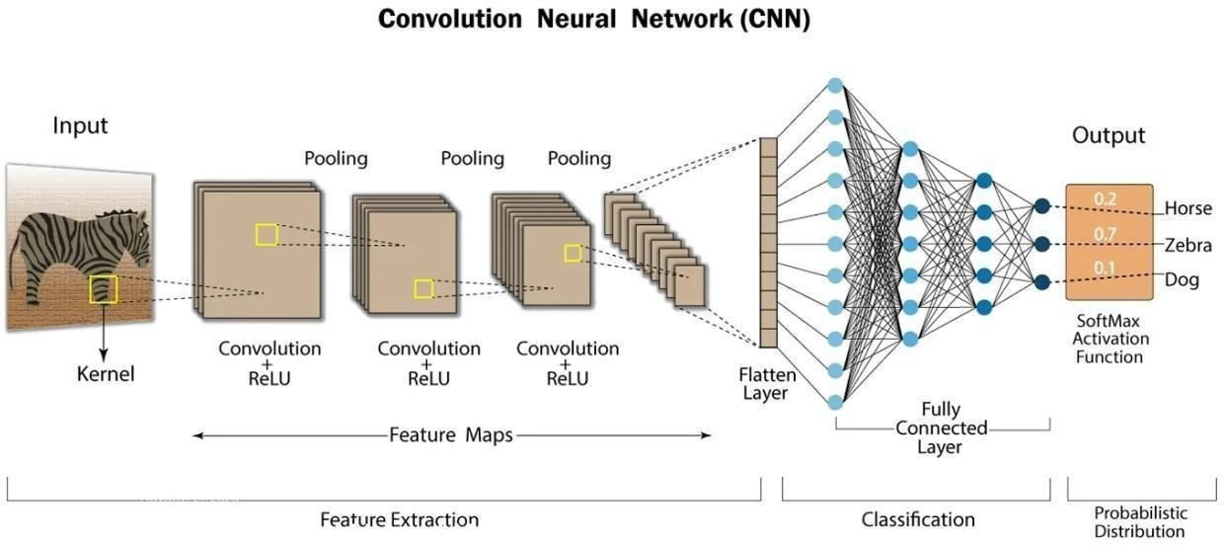

The given diagram represents the working of a Convolutional Neural Network (CNN) used for image classification. In this project, a CNN-based architecture (MobileNetV2) is used to identify whether an animal in a live image belongs to the wild or pet category. The CNN automatically extracts features from the image and performs classification.

Input Image

The input to the CNN is an image captured using a live camera. The image contains the animal to be identified. Before being fed into the CNN, the image is resized and normalized to meet the model’s input requirements.
- Convolution Layer + ReLU Activation

The convolution layer applies multiple filters (kernels) to the input image to extract low-level features such as edges, textures, and shapes.
The ReLU (Rectified Linear Unit) activation function is applied to introduce non-linearity and improve learning efficiency.

Pooling Layer

Pooling layers reduce the spatial size of the feature maps while retaining important information. This helps in:
  - Reducing computational complexity

  - Preventing overfitting

  - Making the model more robust to small variations in the image Max pooling is commonly used in CNNs.

Feature Maps

As the image passes through multiple convolution and pooling layers, a series of feature maps are generated. These feature maps represent increasingly complex patterns such as animal body structure and texture, which are useful for distinguishing wild animals from pet animals.

Flatten Layer

The flatten layer converts the multi-dimensional feature maps into a one-dimensional vector. This vector serves as input to the fully connected layers for classification.

Fully Connected Layer

The fully connected layers combine the extracted features and learn the relationship between these features and the output classes. These layers act as a classifier that determines the final prediction.

Softmax Activation Function

The final layer uses the Softmax activation function, which produces probability values for each output class. In this project, the output probabilities indicate whether the animal is:
  - Wild

  - Pet

The class with the highest probability is selected as the final prediction.

Output

The output of the CNN is the predicted animal category (wild or pet) along with a confidence score. This result is displayed on the dashboard and stored in the database for future reference.

Flow Chart
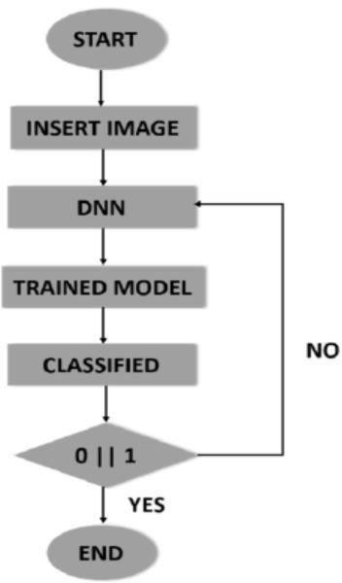

This flowchart represents the deep neural network (DNN)–based image classification process used in the project Identification of Wild and Pet Animals. It illustrates how an input image is processed through a trained deep learning model to generate a classification result.

Step-by-Step Explanation

- Start

The process begins when the system is ready to classify an animal image.

Insert Image

A live image is captured using the camera or provided as input to the system. This image serves as the input for classification.

DNN

The input image is passed to the Deep Neural Network (DNN). In this project, the DNN is implemented using MobileNetV2, which extracts important features from the image such as shape, texture, and patterns.

Trained Model

The DNN uses a pre-trained and fine-tuned model that has already learned the differences between wild animals and pet animals. Since the model is already trained, it is used only for prediction during runtime.

Classified

The trained model classifies the image and generates an output class. This classification indicates whether the animal belongs to the wild category or the pet category.
- Decision (0 | 1)

The decision block represents the classification outcome:

  - 0 → Pet Animal

  - 1 → Wild Animal

Ifa valid classification is produced, the process moves forward.

Ifclassification is not confident (NO), the system can reprocess or accept a new image.

End

Once the classification is successfully obtained, the process ends. The result is displayed to the user and may be stored in the database.

Security and Access Control
Security and access control are important aspects of the proposed system to ensure that only authorized users can access the application and that data is processed safely. Since the system handles live images captured from a camera and stores prediction results, basic security mechanisms are implemented to protect user data and system resources.

User Authentication and Authorization

Access to the web application is restricted to authorized users. Users are required to log in to the system before using the camera and prediction features. This ensures that unauthorized individuals cannot misuse the application or access stored prediction data. Authorization mechanisms control what actions a user is allowed to perform within the system.

Secure Communication
Communication between the frontend web application and the backend server is carried out using secure communication protocols such as HTTP over SSL (HTTPS). This prevents unauthorized interception or tampering of image data and prediction results while they are transmitted over the network.

Controlled Camera Access

The system requests camera access only when required and only after user permission is granted. The browser enforces camera permission policies, ensuring that live images are captured only with explicit user consent. The application does not record or store video streams without user awareness.

Backend Access Control

The backend server exposes APIs only to the frontend application. Direct access to backend endpoints is restricted, reducing the risk of unauthorized requests. Input validation is performed to ensure that only valid image data is processed by the system.

Data Protection and Storage Security

Prediction data stored in the database is protected against unauthorized access. The database is accessible only through the backend server, and direct database access by users is not allowed. Sensitive information such as image paths and timestamps is stored securely.

Model and System Protection

The MobileNetV2 model files are stored on the server with restricted access permissions. This prevents unauthorized modification or misuse of the trained model. Server-side controls ensure that the model is used only for inference and not exposed to external users.

Session Management

User sessions are managed securely to prevent unauthorized reuse of sessions. Sessions expire automatically after a period of inactivity, ensuring that the system remains protected if a user forgets to log out.

User Interaction
User interaction describes how the user communicates with and operates the animal identification system. The system is designed with a simple and intuitive web-based interface to ensure ease of use, even for users with minimal technical knowledge.

Camera Interaction
When the user accesses the application, the system requests permission to use the device’s camera. Once permission is granted, the live camera feed is displayed on the screen. The user can capture a live image directly through the interface. The system captures only a single image at a time and does not record video, ensuring simplicity and reduced resource usage.

Image Submission Interaction
After capturing the live image, the user submits the image for analysis using a single action, such as clicking a button. The system then sends the captured image to the backend server automatically. The user does not need to perform any additional steps, making the interaction smooth and efficient.

Result Display Interaction

Once the backend completes the classification process, the prediction result is sent back to the frontend. The user can view the output on the dashboard, which includes:
- Animal classification (Wild or Pet)

- Identified animal type (if applicable)

- Confidence score of the prediction

The results are displayed clearly to help the user understand the system’s output easily.

Feedback and Response Time

The system provides near real-time feedback after the image is submitted. The user experiences minimal delay between capturing the image and viewing the result. This real-time interaction improves usability and user satisfaction.

Error Handling Interaction

If the system fails to generate a prediction due to poor image quality or other issues, the user is prompted to capture a new image. Clear messages guide the user to retake the image, ensuring smooth interaction without confusion.

Data Viewing Interaction

If prediction history is enabled, users can view previously stored results through the interface. This allows users to review past predictions along with timestamps for reference.

Usability and Interface Design

The user interface follows a simple layout with clearly labeled buttons and minimal controls. The design focuses on:
    - Ease of navigation

    - Clear visibility of results

    - Minimal user input requirements

This ensures that the system is user-friendly and accessible to a wide range of users.

Image Classification System Diagram
The architectural diagram illustrates the overall structure of the system and the interaction between different components.
The architectural diagram represents the complete workflow of the proposed image classification system and explains how different components interact during the training and testing phases. The system is designed to identify whether an animal belongs to the wild animal category or the pet animal category using deep learning.

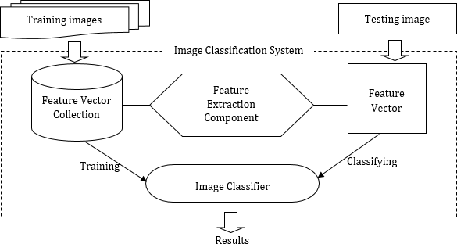

Training Images

Training images consist of labelled animal images belonging to different categories such as wild animals and pet animals. These images are used to teach the deep learning model how to distinguish between different animal types based on visual features like shape, texture, and patterns.
Inthis project, the MobileNetV2 model is trained using a predefined dataset before deployment.

Feature Vector Collection (Training Phase)

During training, features are extracted from each training image using the feature extraction component of the model. These extracted features are converted into numerical representations called feature vectors. The feature vectors capture important characteristics of the images and are stored as part of the training process.

Feature Extraction Component

The feature extraction component is responsible for extracting meaningful visual features from images. In this project, MobileNetV2 acts as the feature extractor. It uses convolutional layers to identify edges, shapes, textures, and patterns that help differentiate wild and pet animals.This component is common to both training and testing phases.

Image Classifier

The image classifier uses the extracted feature vectors to learn classification patterns during training. After training, the classifier is capable of categorizing new images based on learned features.
In this project, the classifier determines whether the input image represents a wild animal or a pet animal.

Testing Image (Live Image)

During the classification phase, a live image captured from the camera acts as the testing image. The image is passed through the same feature extraction component to generate a feature vector.
This ensures consistency between training and testing processes.

Feature Vector(Testing Phase)

The feature vector generated from the testing image represents the important visual characteristics of the live image. This vector is compared against learned patterns in the trained classifier.

Classifying

The classifier analyses the feature vector of the testing image and assigns it to the most appropriate class based on learned knowledge. In this project, the classification result identifies whether the animal in the image is wild or pet, along with a confidence score.

Results
The final output of the system is the classification result. The result is displayed on the user interface and stored in the database for future reference.

CNN Training and Prediction Diagram
The class diagram represents the structure of the system in terms of classes and their relationships.
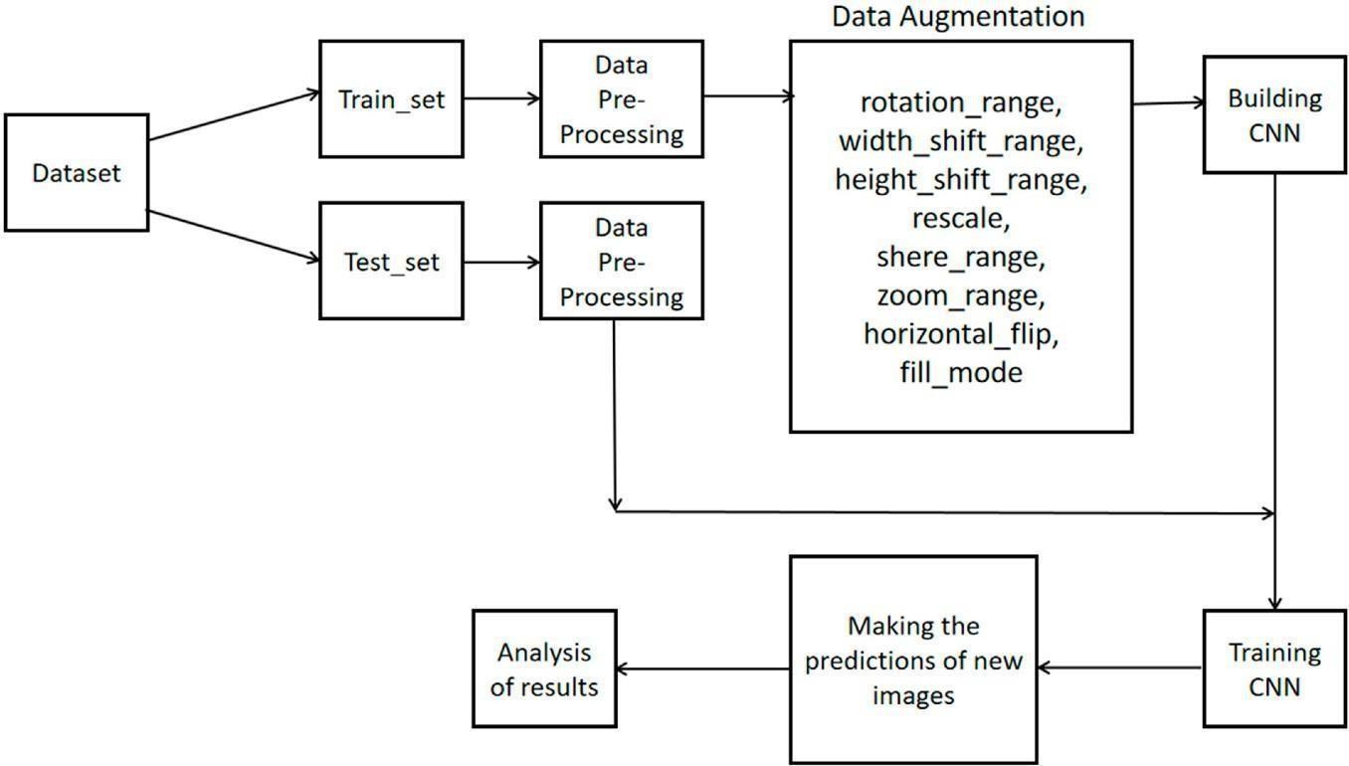

Dataset

The dataset consists of labelled animal images belonging to different categories such as wild animals and pet animals. These images form the foundation for training the CNN model. The dataset is divided into two parts:
- Training set

- Testing set

Train Set and Test Set

- Training Set:
The training set contains images used to teach the CNN model how to distinguish between wild and pet animals.
- Test Set:
The test set contains unseen images used to evaluate the performance of the trained model.

- This separation helps in measuring how well the model generalizes to new data.

Data Pre-Processing

Before feeding images into the CNN, preprocessing is performed on both training and testing images. This includes:
- Resizing images to a fixed input size

- Normalizing pixel values

- Converting images into a suitable numerical format Preprocessing ensures consistency and improves model accuracy.

Data Augmentation

Data augmentation is applied only to the training set to increase data diversity and reduce overfitting. The diagram shows common augmentation techniques such as:
- Rotation

- Width and height shifting

- Rescaling

- Shearing

- Zooming

- Horizontal flipping

- Fill mode handling

These techniques help the model learn from varied image representations.

Building the CNN

After preprocessing and augmentation, the CNN architecture is built. In this project, a MobileNetV2-based CNN is used due to its lightweight nature and suitability for real-time applications. The network consists of convolutional layers, pooling layers, and fully connected layers.

Training the CNN

The CNN is trained using the augmented training data. During training:

- Feature extraction is performed automatically by convolution layers

- The model learns patterns that distinguish wild animals from pet animals

- Modelparameters are updated iteratively to minimize classification error

Making Predictions on New Images

Once the CNN is trained, it is used to make predictions on new images, such as live images captured from the camera in the deployed system. These images pass through the same preprocessing steps before classification.

Analysis of Results

The final stage involves analysing the results obtained from the CNN. This includes:

- Evaluating classification accuracy

- Checking prediction confidence

- Verifying correct identification of wild and pet animals This analysis helps validate the effectiveness of the trained model.

Client-Server Interaction Diagram
The Backend Server acts as the central processing unit of the system. It receives the live image sent from the frontend web application and coordinates all further operations. The backend is responsible for invoking the image preprocessing module, sending the processed image to the MobileNetV2 classification model, and managing the prediction workflow.
After receiving the classification result from the model, the backend formats the prediction output, stores the prediction details in the database, and sends the final result back to the frontend for display. The backend ensures smooth communication between different system components and controls the overall execution flow of the animal identification process. Role in the Sequence Diagram:
- Receives live image from frontend

- Calls preprocessing module

- Sends image to MobileNetV2 model

- Receives prediction result

- Stores result in database

- Sends output back to frontend

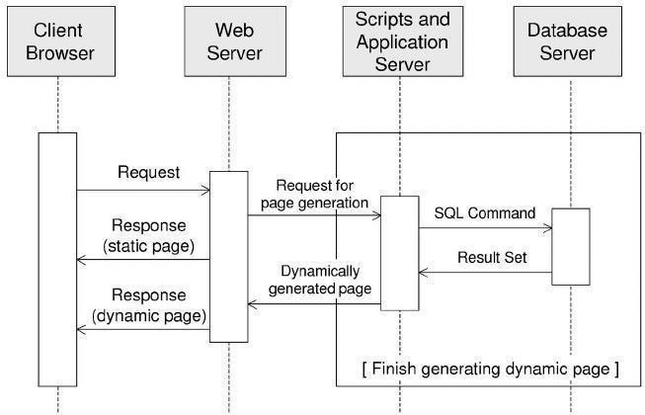

Client Browser

The client browser represents the user’s web browser through which the user accesses the application. In this project:
- The user opens the animal identification web application.

- The browser is responsible for displaying the user interface.

- The user interacts with the application to capture a live image and view prediction results.
The browser sends requests to the web server whenever the user performs an action.

Web Server

The web server acts as an intermediary between the client browser and the application logic.

- It receives HTTP requests from the client browser.

- If the request is for a static resource (such as HTML, CSS, or JavaScript files), the web server directly returns a static page.
- If the request requires processing (such as submitting a live image for classification), the request is forwarded to the application server.
In this project, the web server handles routing and initial request handling.

Scripts and Application Server

The scripts and application server contain the core logic of the system.

- It receives requests from the web server for dynamic page generation.

- It executes backend scripts that handle image preprocessing and classification using the MobileNetV2 model.
- It communicates with the database server to store and retrieve prediction data.

This component dynamically generates responses based on the classification results.

Database Server

The database server stores data required by the application.

- It stores prediction results such as animal category (wild or pet), confidence score, and timestamp.
- It responds to SQL or database queries sent by the application server.

- It returns result sets back to the application server for further processing.

The database is not accessed directly by the client browser, ensuring better security.

Request and Response Flow

The sequence of operations shown in the diagram is as follows:

- The client browser sends a request to the web server.

- The web server checks whether the request is static or dynamic.

- For dynamic requests, the web server forwards the request to the application server.

- The application server processes the request and interacts with the database server if needed.
- The database server returns the required result set.

- The application server generates a dynamic response.

- The web server sends the final response back to the client browser.

Page | 32

CHAPTER 5

IMPLEMENTATION

Model Loading Module

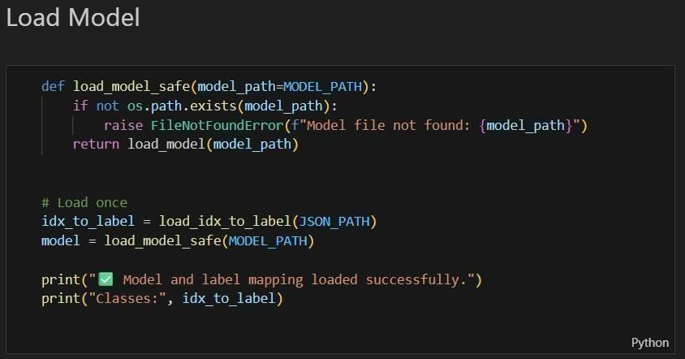

Purpose

The model loading module is responsible for safely loading the trained deep learning model and the corresponding class label mapping required for prediction. This ensures that the system is ready for inference before processing any live image.

Explanation

The function load_model_safe() checks whether the trained model file exists at the specified path. If the model file is not found, an error is raised to prevent the system from crashing during execution. If the file exists, the trained MobileNetV2 model is loaded into memory.

Along with the model, the label mapping file (JSON) is also loaded. This mapping converts numerical prediction indices into meaningful class names such as Wild Animal or Pet Animal. Loading the model and label mapping only once improves performance and avoids repeated loading during predictions.
Why this is important

- Ensures reliable model loading

- Prevents runtime errors

- Improves system efficiency

- Links prediction output to human-readable labels Key functionality
- Checks model file existence

- Loads trained .h5 model

- Loads index-to-label mapping

Image Preprocessing Module

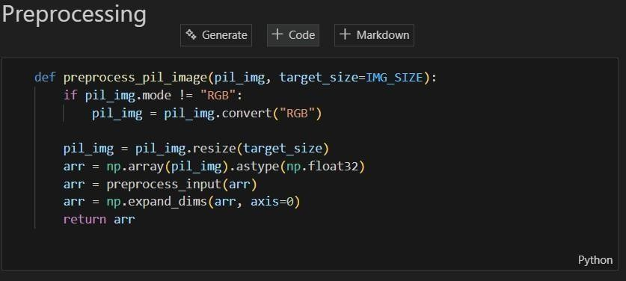

Purpose
The preprocessing module prepares the input image so that it matches the input requirements of the MobileNetV2 model. Proper preprocessing is essential for accurate classification.

Explanation
The function preprocess_pil_image() takes an image as input and performs the following steps:

Color Conversion
If the input image is not in RGB format, it is converted to RGB. This ensures consistency, as MobileNetV2 expects RGB images.

Image Resizing
The image is resized to the target size (e.g., 224×224 pixels). This fixed size is required by the MobileNetV2 architecture.

Array Conversion
The resized image is converted into a NumPy array and cast to floating-point values for numerical processing.

Normalization / Preprocessing
The image array is normalized using the preprocess_input() function, which scales pixel values according to MobileNetV2 requirements.

Batch Dimension Addition
An extra dimension is added to represent batch size, making the image compatible with the model’s input shape.
The processed image is then returned for prediction. Why this is important
      - Ensures compatibility with the trained model
      - Improves prediction accuracy
      - Maintains consistency between training and testing Key functionality
      - RGB conversion
      - Image resizing
      - Normalization
      - Batch formatting

Prediction Module

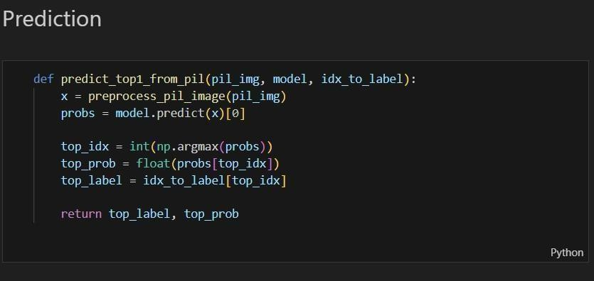

Purpose

The prediction module performs the actual classification of the input image and determines whether the animal is wild or pet.

Explanation

The function predict_top1_from_pil() receives a pre-processed image, the trained model, and the label mapping. The steps involved are:

Preprocessing Call
The input image is first passed to the preprocessing function to ensure it is in the correct format.

Model Prediction
The processed image is fed into the MobileNetV2 model, which outputs probability values for each class.

Class Selection
The class with the highest probability is selected using the argmax function.

Confidence Score Extraction
The probability corresponding to the selected class is extracted as the confidence score.

Label Mapping
The predicted class index is converted into a meaningful label (Wild or Pet) using the index-to-label mapping.
The function returns both the predicted label and its confidence score. Why this is important
      - Core logic of the system

      - Converts model output into understandable results

      - Enables real-time classification Key functionality
      - Executes model inference

      - Identifies top prediction

      - Returns label and confidence

These three modules together form the core implementation pipeline of the system:
- Model Loading → prepares the trained model
- Preprocessing → prepares live image input
- Prediction → classifies the animal as wild or pet
This modular design improves readability, maintainability, and scalability of the system.

CHAPTER 6

SYSTEM TESTING

System testing is an important phase in the software development life cycle that ensures the developed system meets the specified requirements and functions correctly under real-time conditions. In this project, Identification of Wild and Pet Animals using Deep Learning (MobileNetV2), system testing was carried out to validate the performance, accuracy, and reliability of the complete system.
The testing process focuses on verifying the proper working of individual modules as well as their integration, ensuring that live image input is correctly processed and classified.

Objectives of System Testing

The main objectives of system testing in this project are:

- To verify that the system correctly captures live images

- To ensure accurate preprocessing of input images

- To validate the correctness of animal classification results

- To check seamless interaction between frontend, backend, and model

- To ensure the system responds efficiently in real-time scenarios

- To identify and handle possible errors gracefully

Testing Environment

The system was tested in the following environment:

- Operating System: Windows

- Programming Language: Python

- Deep Learning Framework: TensorFlow with Keras

- Model Used: MobileNetV2

- Input Type: Live images captured using camera / image upload

- Interface: Web-based user interface

Types of Testing Performed

- Unit Testing

Unit testing was performed to test individual modules of the system independently.

  - Model Loading Test:
Verified that the trained MobileNetV2 model loads correctly without errors and is ready for prediction.
  - Image Preprocessing Test:
Ensured that images are resized, normalized, and converted into the required format before being passed to the model.
  - Prediction Module Test:
Checked whether the model generates valid predictions along with confidence scores for given input images.
Each module produced the expected output, confirming correct implementation.

Integration Testing

Integration testing was conducted to verify the interaction between different modules of the system.
  - Verified data flow from frontend to backend

  - Ensured that the preprocessing module correctly feeds data into the model

  - Confirmed that prediction results are returned to the frontend without delay This testing ensured smooth coordination among all system components.

Functional Testing

Functional testing was performed to ensure that all system functionalities work as intended.

Functionality | Expected Result | Status
Capture live image | Image captured successfully | Pass
Preprocess image | Correct resizing and normalization | Pass

Functionality | Expected Result | Status
Classify animal | Correct wild/pet output | Pass
Display result | Result shown on dashboard | Pass
All functional requirements were successfully met.

Performance Testing

Performance testing evaluated the system’s response time and efficiency.

  - The system provides classification results within a short time after image submission

  - The lightweight nature of MobileNetV2 ensures low latency

  - Suitable for real-time identification using live images The system demonstrated stable performance during testing.

Error Handling and Validation Testing

The system was tested with invalid or low-quality images to evaluate robustness.

  - The system handles unclear images by prompting the user to try again

  - Missing or incorrect inputs are managed without system failure

  - Basic validation ensures uninterrupted execution This improves system reliability and user experience.

Usability Testing
Usability testing was conducted to evaluate how easily users can interact with the web-based animal classification system. The interface was tested for clarity, ease of navigation, and understandability of the displayed results.
  - The image upload and capture options were found to be simple and intuitive

  - Prediction results, confidence score, and category labels were clearly visible

  - Even non-technical users could operate the system without difficulty

This testing confirms that the system provides a user-friendly experience and requires minimal training.

Page | 40

Security and Access Testing

Basic security testing was performed to ensure safe interaction with the system.

  - Unauthorized access to backend services was restricted

  - Input validation was applied to prevent invalid file formats

  - Only supported image types were accepted by the system

These measures help protect the system from misuse and ensure secure operation during real-time usage.

Compatibility Testing

Compatibility testing was carried out to ensure smooth functioning across different environments.
  - The system was tested on different web browsers

  - Image uploads from various devices were validated

  - The system maintained consistent performance across platforms

This confirms that the application is platform-independent and suitable for diverse users.

Scalability Testing

Scalability testing evaluated how the system behaves with repeated and multiple inputs.

  - Multiple images were tested sequentially without system slowdown

  - The model maintained stable accuracy across repeated predictions

The results indicate that the system can handle moderate real-time usage and can be extended further with enhanced infrastructure.

Reliability Testing

Reliability testing was performed to assess system stability over continuous usage.

  - The model consistently produced correct outputs for similar inputs

  - No crashes or unexpected failures were observed during extended testing This demonstrates the robustness and dependability of the proposed system.

Additional Observations

  - MobileNetV2 proved effective due to its balance between accuracy and computational efficiency
  - The system performs best under proper lighting and clear image conditions

  - Environmental factors such as blur or extreme lighting may slightly affect prediction confidence

Test Results and Analysis

The testing process confirmed that the system functions as expected under normal operating conditions. The model was able to correctly classify animals as wild or pet for most valid images. Minor variations in prediction accuracy were observed under poor lighting conditions, which is expected in image-based systems.

Conclusion
System testing confirms that the proposed system is reliable, efficient, and suitable for real-time identification of wild and pet animals. All modules function correctly both individually and collectively. The successful completion of system testing validates the readiness of the system for deployment and real-world usage.
The extended system testing phase verifies that the developed animal classification system not only meets functional requirements but also performs reliably in real-time environments. The successful evaluation across usability, performance, reliability, and security aspects confirms that the system is well-structured and practical. These results highlight the system’s readiness for real-world deployment and future enhancements such as multi-animal detection and video-based classification.

CHAPTER 7

RESULTS

This chapter presents a detailed analysis of the results obtained after the successful implementation of the proposed system titled “Identification of Wild and Pet Animals using Deep Learning (MobileNetV2)”. The objective of the results section is to evaluate the effectiveness, accuracy, and performance of the system when tested with live images captured through the web application.
The system was tested under various conditions to ensure reliable classification of animals into wild and pet categories. The results demonstrate the ability of the trained deep learning model to perform real-time image classification efficiently.

Experimental Setup

The testing of the system was carried out using a web-based application that allows users to capture live images or upload images for classification. The trained MobileNetV2 model was loaded into the backend server, and all predictions were generated in real time.
The system was tested with images of different animals such as dogs, cats, cows, monkeys, and wild animals. Images were captured under varying lighting conditions and backgrounds to evaluate robustness.

Output Generation

Once a live image is captured, it is sent to the backend server where preprocessing operations such as resizing, normalization, and format conversion are performed. The processed image is then passed to the trained MobileNetV2 model, which outputs a classification result.
The final output includes:

  - Classification label (Wild or Pet)

  - Confidence score representing prediction reliability

  - Display of results on the web dashboard

The entire process occurs within a short time, enabling near real-time identification.

Sample Output Results

The system was evaluated using multiple test cases. Representative results are summarized below:

Test Case | Input Image | Expected Output | Predicted Output | Status
1 | Dog | Pet | Pet | Correct
2 | Cat | Pet | Pet | Correct
3 | Cow | Pet | Pet | Correct
4 | Monkey | Wild | Wild | Correct
5 | Tiger | Wild | Wild | Correct
These results indicate that the system correctly identifies both wild and pet animals in most cases.

Performance Analysis

Performance analysis was conducted to evaluate system responsiveness and efficiency. The use of the lightweight MobileNetV2 architecture enables faster inference with minimal computational overhead.
Observations:

  - The system generates results quickly after image capture

  - Minimal delay is observed during prediction

  - Suitable for real-time image-based applications

This confirms that the system is capable of operating efficiently in practical scenarios.

Accuracy Evaluation

The trained model demonstrated good accuracy for clear and properly captured images. The classification accuracy remained high when:
  - The animal was clearly visible

  - Lighting conditions were adequate

  - The image quality was good

However, minor misclassifications occurred in certain scenarios:

  - Poor lighting

  - Blurred images

  - Partial visibility of the animal

These limitations are common in real-time image classification systems and can be improved with larger datasets and further model tuning.

User Interface Results
The web application interface was tested for usability and responsiveness. The interface successfully:
  - Displays live camera feed or image upload option
  - Shows classification results clearly
  - Displays confidence scores for user understanding
The interface is intuitive and easy to use, requiring minimal user interaction.
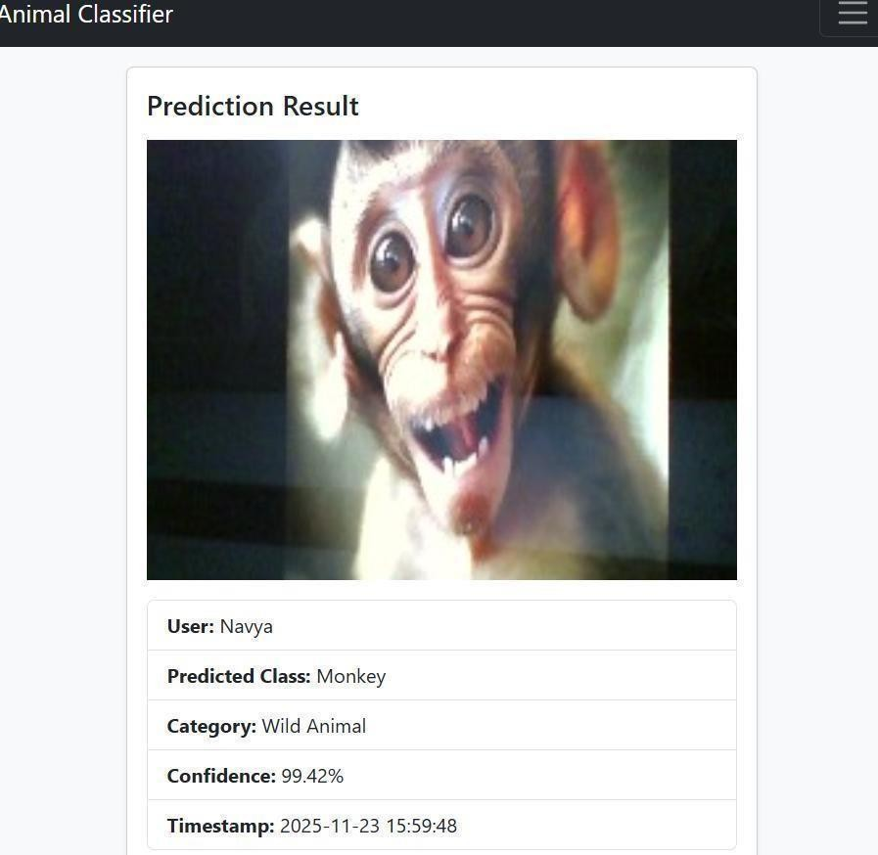

The above figure shows the output generated by the developed web-based animal classification system. A live image of an animal is provided as input through the web application interface. The system processes the image using the trained MobileNetV2 deep learning model and displays the prediction results.
In this example, the system successfully identifies the animal as Monkey and classifies it under the Wild Animal category. The prediction is displayed along with a confidence score of 99.42%, indicating high reliability of the model’s decision. Additional details such as the user name and timestamp are also displayed, which helps in tracking and logging predictions.
This result demonstrates that the proposed system is capable of accurately classifying animals in real time using live image input. The high confidence value confirms the effectiveness of the MobileNetV2 model in distinguishing between wild and pet animals. The clear and structured output display improves user understanding and interaction with the system.
Furthermore, the system provides a user-friendly interface that presents prediction details in a clear and organized manner, making it easy for users to interpret the results without technical expertise. The inclusion of confidence score enhances transparency by indicating the certainty level of the model’s prediction.
The real-time processing capability of the system makes it suitable for practical applications such as wildlife monitoring, animal safety systems, and smart surveillance solutions. By leveraging a lightweight yet powerful model like MobileNetV2, the system achieves a good balance between accuracy and computational efficiency.
Overall, this output validates the robustness and practicality of the developed web-based animal classification system, demonstrating its potential for deployment in real-world scenarios involving live image-based animal identification.

CHAPTER 8

CONCLUSION AND FUTURE WORK

CONCLUSION
The project titled “InnoWild: AI-Driven Identification of Wild and Pet Animals in India” successfully demonstrates the effective application of deep learning techniques for real-time animal classification. The primary goal of the project was to design and implement an efficient system capable of distinguishing between wild and pet animals using live image input, and this objective has been achieved with satisfactory accuracy and reliability.
The developed system integrates a web-based user interface with a deep learning backend, allowing users to capture or upload live images of animals for classification. The images undergo essential preprocessing steps such as resizing, normalization, and noise reduction to ensure compatibility with the trained model. The use of the MobileNetV2 architecture plays a crucial role in achieving high performance, as it offers an optimal balance between classification accuracy and computational efficiency. This makes the system suitable for real-time applications, even in environments with limited hardware resources.
Extensive testing and evaluation confirm that the system performs consistently well under normal operating conditions. The model is capable of accurately classifying animals into wild and pet categories, and the inclusion of confidence scores provides transparency and helps users assess the reliability of predictions. The system also demonstrates robustness by handling invalid inputs and low-quality images without system failure, thereby improving overall reliability and user experience.
The seamless integration between the frontend, backend, and deep learning model ensures smooth data flow and responsive interaction. The web-based interface presents results in a clear and structured manner, enabling easy understanding even for non-technical users. Additionally, the system’s modular design allows for scalability and future enhancements without significant restructuring.
From an application perspective, the proposed system has significant practical relevance. It can be effectively utilized in areas such as wildlife monitoring, forest surveillance, animal safety systems, smart agriculture, and residential security solutions. By automating the process of

animal identification, the system reduces manual effort, minimizes human error, and supports faster decision-making in critical situations.
In conclusion, this project successfully validates the potential of deep learning-based approaches in animal identification tasks. The achieved results highlight the effectiveness, reliability, and practicality of the proposed system. The project not only fulfills its intended objectives but also lays a strong foundation for further research and development in the domain of intelligent animal monitoring systems.
Fig., System Outcome Diagram

DEPT. OF CSE, CITNC
Live Image Input
│
▼
Image Preprocessing (Resize, Normalize)
│
▼ MobileNetV2 Model
(Deep Learning)
│
▼
Animal Classification (Wild / Pet)
│
▼ Confidence Score
│
▼
User-Friendly²O⁰ ²u⁵t⁻p²⁶ut (Web Interface)

FUTURE WORK

While the current system delivers satisfactory performance, several enhancements can be incorporated to further improve functionality, scalability, and real-world applicability. The following future extensions are proposed:

Expansion of Dataset

The system’s accuracy and generalization capability can be enhanced by training the model on a larger and more diverse dataset, including additional animal species, different age groups, and images captured under varying environmental conditions.

Real-Time Video Stream Processing
Future versions of the system can support continuous video input instead of single image uploads. This would enable real-time animal detection, tracking, and behavior analysis, which is highly beneficial for surveillance and wildlife monitoring applications.

Integration of Intelligent Alert System

An automated alert mechanism can be implemented to notify users or authorities when a wild animal is detected. Alerts can be delivered through notifications, emails, or SMS, improving safety and preventive measures in sensitive areas.

Mobile Application Development

The system can be extended into a mobile application for Android and iOS platforms, allowing users to perform animal identification using smartphone cameras, thereby increasing accessibility and practical usability.

Advanced Model Enhancement

More advanced deep learning architectures such as EfficientNet, YOLO-based models, or ensemble approaches can be explored to further improve classification accuracy and detection speed.

Environmental Adaptability Improvements

Techniques such as image enhancement, adaptive preprocessing, and data augmentation can be incorporated to improve system performance under poor lighting, occlusion, and complex background scenarios.

Multi-Animal Detection

Future work can include detecting and classifying multiple animals within a single image or video frame, enabling more comprehensive analysis in real-world environments.

REFERENCES
- A. Krizhevsky, I. Sutskever, and G. E. Hinton, “ImageNet Classification with Deep Convolutional Neural Networks,” Advances in Neural Information Processing Systems (NIPS), vol. 25, pp. 1097–1105, 2012.

- K. Simonyan and A. Zisserman, “Very Deep Convolutional Networks for Large-Scale Image Recognition,” International Conference on Learning Representations (ICLR), 2015.

- A. Howard et al., “MobileNets: Efficient Convolutional Neural Networks for Mobile Vision Applications,” arXiv preprint arXiv:1704.04861, 2017.
- M. Sandler, A. Howard, M. Zhu, A. Zhmoginov, and L. Chen, “MobileNetV2: Inverted Residuals and Linear Bottlenecks,” Proceedings of the IEEE Conference on Computer Vision and Pattern Recognition (CVPR), pp. 4510–4520, 2018.

- Y. LeCun, Y. Bengio, and G. Hinton, “Deep Learning,” Nature, vol. 521, no. 7553, pp. 436–444, 2015.

- R. Girshick, “Fast R-CNN,” Proceedings of the IEEE International Conference on Computer Vision (ICCV), pp. 1440–1448, 2015.

- J. Redmon and A. Farhadi, “YOLOv3: An Incremental Improvement,” arXiv preprint arXiv:1804.02767, 2018.

- O. Russakovsky et al., “ImageNet Large Scale Visual Recognition
Challenge,” International Journal of Computer Vision, vol. 115, no. 3, pp. 211–252, 2015.
- F. Chollet, Deep Learning with Python, Manning Publications, 2017.

- TensorFlow Documentation, “TensorFlow: Large-Scale Machine Learning on Heterogeneous Systems,” Available: https://www.tensorflow.org
- Keras Documentation, “Keras: Deep Learning for Humans,” Available: https://keras.io

- OpenCV Documentation, “Open Source Computer Vision Library,” Available: https://opencv.org

- N. Dalal and B. Triggs, “Histograms of Oriented Gradients for Human
Detection,” Proceedings of the IEEE Conference on Computer Vision and Pattern Recognition (CVPR), 2005.
- S. Ren, K. He, R. Girshick, and J. Sun, “Faster R-CNN: Towards Real-Time Object Detection with Region Proposal Networks,” IEEE Transactions on Pattern Analysis and Machine Intelligence, vol. 39, no. 6, pp. 1137–1149, 2017.

- J. Deng et al., “ImageNet: A Large-Scale Hierarchical Image Database,” IEEE Conference on Computer Vision and Pattern Recognition (CVPR), 2009.

